GuitarCoach Revision 1.0.0 Developed by GuitarCoach Team
Release Plan
Revision Date: 1/14/26
Release Name: GuitarCoach
High Level Goals:
● Create a personalized profile that determines the skill level of a user, defines their “music taste” by using the Spotify API, and considers the user’s future goals.
● Integrate an AI planner that generates practice plans that includes song recommendations, technique exercises, and youtube video suggestions.
● Allow the user to receive personalized feedback through an audio upload feature. This lets the user record themselves playing and then see tips and recommendations for how to improve.
Sprints:
Sprint 1
User Stories | Story  Points | Priority
As a user, I want to be able to create a username and password so my account can be secure. | 5 | Medium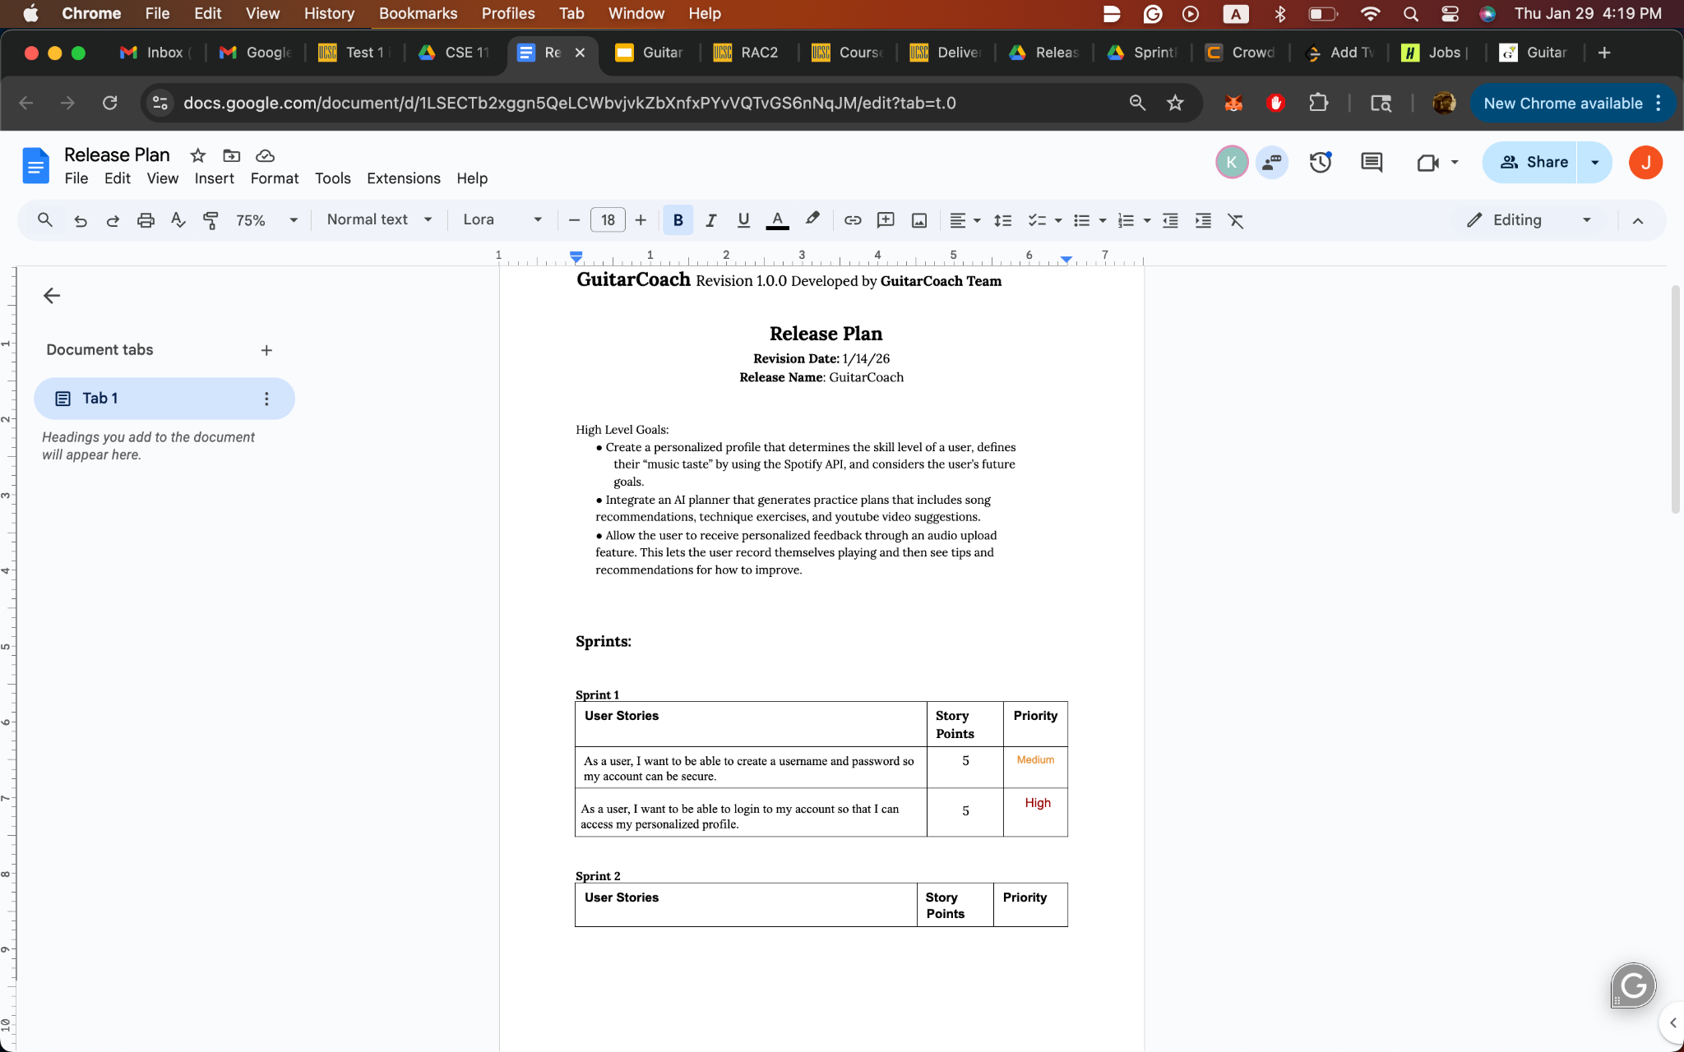
As a user, I want to be able to login to my account so that I can access my personalized profile. | 5 | High

Sprint 2
User Stories | Story  Points | Priority
As a user, I want to link my Spotify account to the application so that my music profile can be personalized. | 5 | High
As a user, I want my skills to be accurately described so that the practice plans match my ability. | 5 | High
As a user, I want to be able to access my profile so I can make changes if necessary. | 3 | Medium
As a user, I want to be able to answer a questionnaire to determine my skills as a guitarist. | 3 | Low

Sprint 3
User Stories | Story  Points | Priority
As a user, I want to be able to see what and how to practice so that I can improve. | 8 | High
As a user, I want to be able to see a future practice schedule so that I have a plan of what to practice throughout the week | 5 | High
As a user, I want to be able to center my practicing around a specific song so that I can see what it will take to learn. | 5 | Medium

Sprint 4
User Stories | Story  Points | Priority
As a user, I want to receive useful, specific feedback so that I can improve my playing. | 8 | High
As a user, I want to track my progress so that I can see my development and stay motivated. | 5 | Medium

Product Backlog (a list of all desired work on the project):
- As a user, I want to be able to login with my username and password so that I can access my account.
- As a user, I want to be able to reset my password if I forget it so that I can still access my account and its history.
- As a user, I want to be able to create an account with a unique username and password.
Sanity Check:
We should be good, Sprint 4 is highly possible due to good progress in Sprint 1.

